GERARD MANLEY HOPKINS

Pied Beauty

Glory be to God for dappled things --
For skies of couple-colour as a brinded cow;
For rose-moles all in stipple upon trout that swim;
Fresh-firecoal chestnut-falls; finches' wings;
Landscape plotted & pieced -- fold, fallow, & plough;
And áll trades, their gear & tackle & trim.
All things counter, original, spáre, strange;
Whatever is fickle, frecklèd, (who knows how?)
With swíft, slów; sweet, sóur; adázzle, dím;
He fathers-forth whose beauty is pást change:
Práise hím.

- Mark the stressed syllables in any three lines.
- What is Hopkins’ poem about?

- How do the sound, structure, and images help us get his idea?

God’s Grandeur
The world is charged with the grandeur of God.
It will flame out, like shining from shook foil;
It gathers to a greatness, like the ooze of oil
Crushed. Why do men then now not reck his rod?
Generations have trod, have trod, have trod;
And all is seared with trade; bleared, smeared with toil;
And wears man’s smudge and shares man’s smell: the soil
Is bare now, nor can foot feel, being shod.

And for all this, nature is never spent;
There lives the dearest freshness deep down things;
And though the last lights off the black West went
Oh, morning, at the brown brink eastward, springs—
Because the Holy Ghost over the bent
World broods with warm breast and with ah! bright wings.

QUESTIONS:
- How closely does Hopkins follow the Petrarchan sonnet form? What does he change/ add?

- Mark the stressed syllables in any three lines of this poem. Compare the patterns to “Pied Beauty.” Is there any difference in the way Hopkins works the Sprung Rhythm here?

- What is Hopkin’s central theme in this poem?

- In what ways would this poem make a good slogan (a long one) for a modern environmentalist group? In what ways might this poem fail in this?

Binsey Poplars
BY GERARD MANLEY HOPKINS
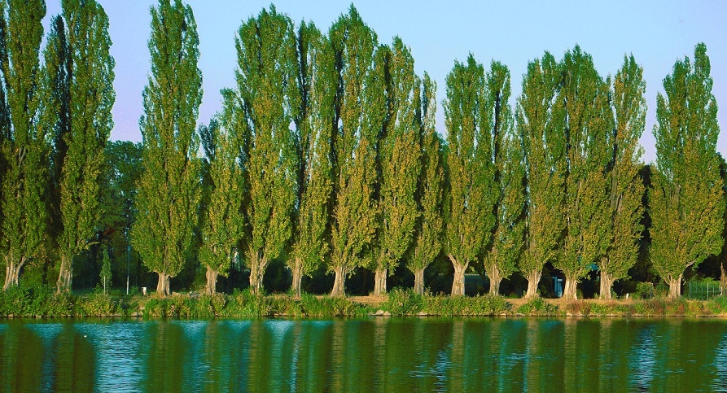
felled 1879
My aspens dear, whose airy cages quelled,
Quelled or quenched in leaves the leaping sun,
All felled, felled, are all felled;
Of a fresh and following folded rank
Not spared, not one
That dandled a sandalled
Shadow that swam or sank
On meadow & river & wind-wandering weed-winding bank.

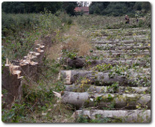
O if we but knew what we do
When we delve or hew —
Hack and rack the growing green!
Since country is so tender
To touch, her being só slender,
That, like this sleek and seeing ball
But a prick will make no eye at all,
Where we, even where we mean
To mend her we end her,
When we hew or delve:
After-comers cannot guess the beauty been.
Ten or twelve, only ten or twelve
Strokes of havoc unselve
The sweet especial scene,
Rural scene, a rural scene,
Sweet especial rural scene.
Source: Gerard Manley Hopkins: Poems and Prose (Penguin Classics, 1985)

QUESTIONS:
- What is the rhyme scheme?
- What is the effect of the Sprung Rhythm on the reader? (hint- think about onomatopoeia…)
- What is the effect of the last three lines in comparison to the topic of the poem?
- After reading these three poems, what would you say Hopkins values?
- Write a poem about something special in nature. Use sprung rhythm- remember, all that matters is the number of stressed syllables in the line. Invent some words like Hopkins does!

Of two or more colors in blotches, variegated
Marked with spots
Brownish orange in color with streaks of gray
flecked
Freshly fallen chestnuts, bright as coals
Divided into fields used as pastures (“fold”) lying fallow, or ploughed for cultivation. The landscape thus appears like rectangles of different colors.
Equipment
rare
gold foil which glares in the light
Droplets of oil scattered by crushing, gathered back together again. The idea here is that the greatness of God, however diffused in the world, cannot be diminished.
Reckon with, heed

